**Engr 304 SW Lab 1 Name: Daniel Ackuaku**

**Section: B**

|  |  |  |  |
| --- | --- | --- | --- |
| **Constant or Variable** | **Register Assigned to hold the value** | **Final Hex Value at the end of execution** | **Final Decimal Value at the end of execution** |
| A | r9 | 0xdeadbeef | 3735928559 |
| B | r10 | 0xab7a8bbc | 2876935100 |
| C | r11 | 0x22222222 | 572662306 |
| X | r12 | 0x55555555 | 1431655765 |
| Y | r13 | 0x0001e74e | 124750 |
| Z | r14 | 0x00f3a700 | 15968000 |
| W | r15 | 0xddffffdd | 3724541917 |
| not C | r16 | 0xdddddddd | 3722304989 |

Screen capture (snip) of your register usage:

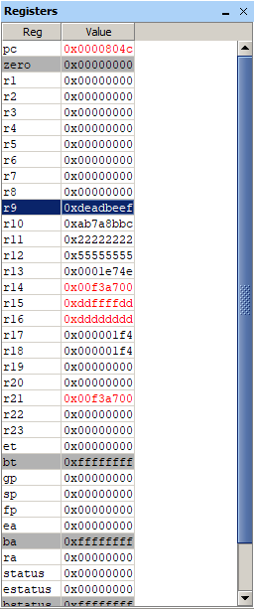

Assembly code listing: (see notes in the Formatting Software Printouts document on formatting this properly)

/***************************************************************************/

/* Name: Daniel Ackuaku */

/* Course: Engineering 304L */

/* Lab: 1 */

/* Date: 2/7/2019 */

/***************************************************************************/

/*TEMPLATE: fill in the title block above */

/* The ".include nios_macros.s" assembler directive includes NIOS macros for use in the program */

.include "nios_macros.s"

/* The word-aligned address of the reset vector, value is taken from the cpu configuration in SOPC builder. */

/*TEMPLATE: replace 0x00 with the appropriate address */

.equ RESET_VECTOR, 0x00

/* The ".text" assemlber directive indicates the beginning of the code section of the program */

.text

/* The ".org RESET_VECTOR" assembler directive places the main routine at the reset address */

.org RESET_VECTOR

/* The ".global _start" assembler directive exports the "_start" label as an external symbol */

.global _start

/* The "_start" label identifies the program start location for the debugger */

_start:

/*******************/

/**** MAIN ****/

/*******************/

/* Pseudo-code for this program is as follows */

/* Initialize variables (sum), initialize registers, etc

Begin LOOP

Read value from array

If value=0, exit the loop, else

Add value to sum variable

Increment loop index (or pointer address)

return to "Begin LOOP"

*/

/**** init ****/

MAIN_PROG_INIT:

movia r9, 0xDEADBEEF /* load the hexadecimal number into the r9 register */

movia r10, 0xAB7A8BBC /* load the number 2876935100 into the r10 register */

movia r11, 0x22222222 /* load the number 572662306 into the r11 register */

movi r17, 0x1F4 /* load the number 500 into the r17 register */

movi r18, 0x1 /* load the number 1 into the r18 register */

/**** run ****/

SUM_OF_Y:

add r13, r13, r18 /* add r18 to the value in r13 (1 + Y ) */

addi r18, r18, 1 /* increment r18 by 1 */

bne r18, r17, SUM_OF_Y /* loop back to the top if r18 is not 500 */

/**** run ****/

SUM_OF_X:

sub r12, r9, r10

add r12, r12, r11

/**** run ****/

Z_XOR:

srai r20, r14, 3 /* shift r14 3 bits to the right and store in r20 */

slli r21, r13, 7 /* shift r14 7 bits to the left and store in r21 */

xor r14, r20, r21 /* r14 = r20 xor r21 */

/**** run ****/

W:

movi r22, 0 /* load the hexadecimal number into the r22 register */

nor r16 , r22, r11 /* create a not using thee nor of the zero register and r11 storing the result in r16 */

or r15, r14, r16 /* r15 = r14 xor r21 */

/**** destroy ****/

MAIN_PROG_END:

br MAIN_PROG_END /* infinite loop to keep program from going into the weeds */

/*******************/

/**** DATA ****/

/*******************/

/* The ".data" directive identifies the section of the program that defines global variables */

.data

/* The ".end" assembler directive indicates the end of the program and

all following lines are discarded */

.end